Olivia Nauman

Kyle Rector

Human Computer Interaction

08/31/2017

1. The website that I am using is the Centers for Medicare and Medicaid Services (CMS) website. (<https://www.cms.gov/>)
2. This website exists to provide more information about CMS and the services they offer. Additionally, the website provides recent news concerning CMS and statistics surrounding CMS and its programs.
3. A typical user may be entering this website to gain knowledge about a program offered by CMS or find a statistic for a presentation or research project concerning health.
4. I would say that the functionality is at the level (equal to) I expected. It doesn’t seem to go above and beyond to provide any certain feature, but it is easy enough to search or ‘Ask for Help’ for whatever I may be looking for, as shown in Figure 1.



**Figure 1**

1. **Usability Goals:**
2. Effectiveness is important, especially for an informational website, because if the user does not leave feeling as though they accomplished a task accurately and completely then they will likely not return.
3. Efficiency is valuable because a user may become disheartened if it takes a great amount of effort to access the information they need and complete a task.
4. Learnability matters because a user is more likely to continue using a resource if they do not become stressed by their inability to learn to use the resource properly.
5. Safety is important, especially for government websites, because data that can be linked back to a particular person must be protected.
6. **User Experience Goals:**
7. Helpful websites will allow the user to feel productive and accomplished.
8. Aesthetically Pleasing websites will keep the interest of the user moreso than those which are not pleasing.
9. Enjoyable websites are more likely to have returning users and users who recommend the website to their peers.
10. Motivating websites encourage further use of themselves.
12. **Effectiveness** will be judged on a variety of factors. First, I will be judging the naming conventions of the linked-buttons. Additionally, I will be judging the headlining or main images or stories chosen to represent the website; ideally these should be stories relevant to the greater population and not just a small group of people. I will be giving the effectiveness a score from 1-10 to further communicate my ranking.
13. **Efficiency** will ultimately come back to the idea of how quickly I am able to reach the information I am hoping to. I will judge the layers of links I am put through to get to a specific topic. I will also judge my ability to get help more quickly in the form of help tabs and a search bar. I will be giving the efficiency a score from 1-10 to further communicate my ranking.
14. **Helpfulness** will be judged by the ability of the website to give me information which is broken down to a basic, high-school level of understanding. Additionally, how many resources will be provided in case I need additional assistance? Are there options for alternative languages on the website? I will be giving the helpfulness a score from 1-10 to further communicate my ranking.
15. **Aesthetically Pleasing** is a very subjective category. However, I will be using factors like color and placement to judge my website. Also, I will be questioning the text style and quantity. I will be giving the aesthetics a score from 1-10 to further communicate my ranking.
17. The website did a great job at breaking the linked buttons down into differentiated buttons to guide the linked webpages. CMS is a huge organization, so this would not be an easy task. The headline featured three captions: Covering more Americans, Making Americans healthier by preventing illness, and Coordinating better care & lowering costs. All of these captions I found to be applicable to any person coming to the site that is eligible for CMS’s services or directly affected by the decisions of CMS (i.e. U.S. citizens because it is a government organization). Overall, I found this effectiveness to sit at a full 10; information was effectively available in a format that provides a broad-to-specific view and immediate information is relevant to anyone stopping by the page.
18. This website, despite being effective, is not the most efficient. Although a search bar exists, which definitely helps, any search for information beyond the most basic definitions will definitely take a few clicks (and that is assuming that you know the proper section to click next). Below, in Figure 2, is an example of one page digression which took me three clicks to access. Overall, I would give this website a 7 for efficiency. It wasn’t awful and information definitely is accessible, it just takes a little bit of work to get where you need to. Considering the extremely large amount of content, I am not sure what may be a way to combat this. However, I would recommend an extremely accurate searching resource to assure users stay interested while locating their content.

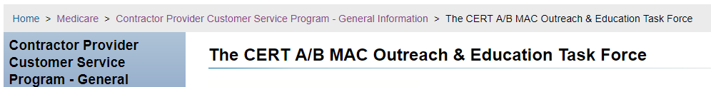

**Figure 2**

1. I found this website to be extremely helpful. Even information on complex models is accompanied by multiple supplemental resources to further understand something very multifaceted. In fact, they apparently have a policy called ‘plain writing’ which requires staff to write in a way that allows for common people to understand the topics, as seen in Figure 3. I was also able to find a very clear option to translate the webpage to Spanish! Overall, I am giving this website a 10 for helpfulness. It seems that they are doing their best to make this a priority on their website.

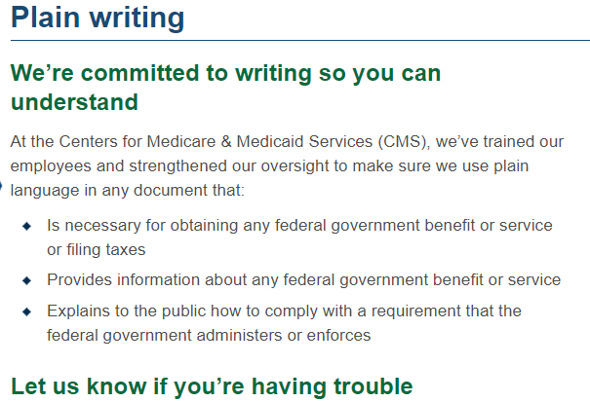

**Figure 3**

1. I found this website to be very aesthetically pleasing. Important resources are outlined by colored boxes, which make them very obvious. The font used is very easy to read and looks professional. Additionally, there is an option to make text larger if you so choose, which can be seen in Figure 4. I initially found the number of words per page to be a bit overwhelming, but this feature definitely helps that! Overall, I would give a 9 out of 10 for aesthetics. I would like to see more color on the pages than just the gold, white, and blue currently in use.



**Figure 4**

Overall, I thought the website was designed with many Usability Goals and User Experience Goals in mind. I personally would have changed a few minor things aesthetically and would have tried to find a way to increase efficiency. One way that I think efficiency may be increased would be adding drop down menus off of the existing menu links. Nevertheless, I found this website to set a great example of how a complex professional organization might structure their website.